# **DECLARATION**

We……….., and …………………. hereby declare that this Project “AUTOMATIC FOLK LIFT WITH SPEED CONTROL” submitted in partial fulfillment of the requirement for the Advanced Diploma in ELECTRONICS AND TELECOMMUNICATION TECHNOLY, at Rwanda Polytechnic-Integrated Polytechnic Regional College-Huye, is our original work and has not previously been submitted elsewhere. Also, we declare that a complete list of references is provided indicating all the sources of information quoted or cited.

Name 1

Signature………………………….

Date……. /………/……………….

Name 2

Signature………………………….

Date……. /………./…………..

# **CERTIFICATION**

This is to certify that the Project work entitled “Automatic folk lift with speed control” Submitted by ………………. and ……………….., in partial fulfillment of the requirement for the award of the degree Electrical and Electronic engineering department in Electronics and telecommunication technology is a record of work carried out by him under my guidance.

Supervisor:

Signature …………………………...

Date : …... /…... / 2021

Head of department of Electrical and Electronics Engineering

MCS. Theophile BIRAMAHIRE

Signature …………………………...

Date : …... /…... / 2021

# **DEDICATION**

We dedicate this work to our beloved parents, brothers and sisters who may see this work as a fruitful result of their support, encouragement and love. Who have always been by our side in time of need, since we started our academic study till today. Finally, we dedicate it to all our classmates for the part they played in our studies during those long and exciting years.

# **ACKNOWLEDGEMENTS**

Our first gratitude, appreciation and thanks goes to the Almighty God, who guided us through this journey that was not easy.

We express our deepest thanks to Electrical and Electronics Engineering department for taking part in useful decision and giving necessary advices and guidance and arrange all facilities to make life easier. I choose this moment to acknowledge their contribution gratefully.

It is our radiant sentimental to place on record our best regards, deepest sense of gratitude toour supervisor ………………………. for his careful and precious guidance which were extremely valuable for our study both theoretically and practically, for his technical, wise advice, inspiration, motivation and guidance support during the elaboration of this project.

We highly express our thanks and gratitude for IPRC Huye administration and others staffs for their great help. Moreover, we express and appreciate our school practice supervisor for his help, advice throughout our teaching practice.

We wish to express our sincere thanks to Rwanda Polytechnic/ IPRC Huye for giving us the opportunity of making practice exercises to the department of Electrical and Electronics Technology especially option of Electronics and Telecommunication.

# **ABSTRACT**

Nowadays smart systems are being used in every aspect of our daily life to improve our standards of living, mainly as industrialization continues to grow the need of using automated systems to carry out tasks in order to improve the production is at a high demand, using these robots increases the production and precision in the production, self-driving robots is one among the automated systems , this system can be achieved in many different ways but in this project ,it was achieved using IR (infrared)sensors to follow a pre-determined line path, adding a mechanical lift to the robot makes it’s uses extend to the packaging process without any human operator to control the motions of the robot , this project report illustrates the steps, materials and components needed to design and implement project.

**TABLE OF CONTENTS**

**DECLARATION** 2

**CERTIFICATION** 3

**DEDICATION** 4

**ACKNOWLEDGEMENTS** 5

**ABSTRACT** 6

**TABLE OF FIGURES** 9

**LIST OF ABBREVIATIONS** 10

**CHAPTER ONE: INTRODUCTION** 11

1.1 General background 11

1.2 Problem statement 11

1.3 Objectives 12

1.3.1 Main objective 12

1.3.2 Specific objectives 12

1.4 Scope of project 12

1.5 Project organization 12

**CHAPTER TWO: LITERATURE REVIEW** 13

2.1 Introduction 13

2.2 Electronic components 13

2.2.1 Microcontroller 13

*2.2.1.1* Arduino uno 13

2.2.2 Sensors 14

*2.2.2.1* IR sensor/ infrared sensor 14

*2.2.2.2* HC-SR04 Ultrasonic sensor . 18

2.2.3 Actuators 19

*2.2.3.1* DC motor 19

2.2.4 Switching devices 20

*2.2.4.1* L298N Driver 21

2.2.4.2 5VDC Relay 22

2.2.4.3 Transistors 23

**CHAPTER THREE: METHODOLOGY** 24

3.1 Introduction 24

3.2 Methodology 24

3.2.1 Observation 24

3.2.2 Documentation 24

3.3 Softwares used 25

3.3.1 Arduino IDE 25

**CHAPTER FOUR: PRESENTATION AND RESULT ANALYSIS** 26

4.1 Introduction 26

4.2 Block diagram 26

4.2.1 Block diagram description 26

4.2.1.1 Arduino UNO 26

2.1.1.1 Infrared sensors 27

2.1.1.1 Ultrasonic sensor 28

2.1.1.1 Lift mechanism 28

*4.3* Flow chart 29

4.4 Circuit diagram 30

4.5 working principle 30

4.6 Implementation of the project 32

**CHAPTER FIVE. CONCLUSION, SUMMARY AND RECOMMENDATION** 33

5.1 Conclusion 33

5.2 Recommendation 33

**REFERENCES** 34

**APPENDIES** 35

# **TABLE OF FIGURES**

*Figure 1: Arduino uno* [4] 16

Figure 2: IR transmitter [5] 18

Figure 3:IR receiver [5] 18

Figure 4:IR sensor obstacle detection [5] 19

Figure 5:Ultrasonic sensor 20

Figure 6: DC electric motor [6] 22

Figure 7:L298N motor driver [8] 23

Figure 8:Relay 24

Figure 9:NPN transistor BC547 [9] 25

Figure 10: block diagram 28

Figure 11:IR sensor on a black and white surface 29

Figure 12:IR sensors on different directions 30

Figure 13: flow chart 31

Figure 14: Full circuit diagram 32

Figure 15: final implemented project 34

# **LIST OF ABBREVIATIONS**

**AC**: Alternating current

**AVR:** Automatic Voltage Regulation

**dB**: decibel

**DC**: Direct current

**IC**: integrated circuit

**ICSP**: in circuit serial programming

**IDE**: Integrated Development Environment

**IPRC**: Integrated Polytechnic Regional College

**MHz**: Megahertz

**PC**: Personal Computer

**PCB**: Printed Circuit Board

**PWM**: Pulse Width Modulation

**RAM**: Random access memory

**ROM**: Read Only Memory

**RP**: Rwanda Polytechnic

**SMS**: Short Message Service

**SQL**: Structured Query Language

**TTL**: transistor transistor logic

**UART**: Universal asynchronous receiver transmitter

**USB**: Universal Serial Bus

**VCC**: Voltage common collector

**VDC**: Direct Current voltage

# **CHAPTER ONE: INTRODUCTION**

## General background

The history of robots has its origins in the ancient world. During the industrial revolution, humans developed the structural engineering capability to control electricity so that machines could be powered with small motors. Several definitions can be used to define a robot, one of them include “A reprogrammable, multifunctional manipulator designed to move material, parts, tools, or specialized devices through various programmed motions for the performance of a variety of task”

The first uses of modern robots were in factories as industrial robots. These industrial robots were fixed machines capable of manufacturing tasks which allowed production with less human work. Digitally programmed industrial robots with artificial intelligence have been built since the 2000s [1].

**Mostly Robots are used to works in areas that can posse danger to man, to carry out heavy tasks, and also to increase production since the don’t gate tired, carrying heavy objects is one of the things that can expose danger to the human life, and also working for a long period of time. That’s why we used a line follower to achieve an automatic control. Generally, a line follower robot is a self-operating mobile machine that follows a line drawn on the floor, the line path can be black or white (inverted). Adding system to detect the object and a mechanical system to lift the object and follow the line path and place it to the desired location, an automatic folk lift is achieved, since the speed can vary with the material lifted, a way to control the speed of the robot is also provided and finally an automatic folk lift with speed control is achieved** [2]**.**

## Problem statement

In the current system in use the operator drives the lift machine, and this system in use presents some problems which include, the operator’s life may be in danger due to accidents that may rise from the falling objects being parked, the operator gets tired and this affects the production in industries, the need of more man labor which increases the production costs.

## Objectives

### Main objective

The main objectives of this project is to Design and implement AUTOMATIC FOLK LIFT WITH SPEED CONTROL.

### Specific objectives

The specific objectives of this project are:

1. To build a line follower robotic car that will follow the path predetermined.
2. To build a build a mechanical system on the robotic car that will be used to lift the objects (folk lift).
3. To build a add control system that controls the speed of the robot.

## Scope of project

This project is limited areas whose floor is not black and only a black as the color of the path, since it uses sensors to follow the black path, any change in the color could result in the system to malfunction. And also the speed isn’t changed automatically, an operator is required to change the speed of the robot.

## Project organization

This report discusses the design and implementation of automatic folk lift with speed control. It is subdivided into five chapters the first chapter is the Introduction, the second chapter is the literature review, the third chapter is Methodology, the fourth chapter is presentation and result analysis and the fifth chapter is Conclusion, summary and recommendations

# **CHAPTER TWO: LITERATURE REVIEW**

## Introduction

In this chapter we have reviewed different types of components that were used while implementing this project. these components include, Microcontroller, sensors, actuators, indicators and switching devices.

## Electronic components

### Microcontroller

A microcontroller is a small computer on a single metal-oxide-semiconductor (MOS) integrated circuit (IC) chip. A microcontroller contains one or more CPUs (processor cores) along with memory and programmable input/output peripherals. While designing and implementing this project we used Arduino uno microcontroller [3].

#### Arduino uno

Arduino UNO is a microcontroller board based on the **ATmega328P**. It has 14 digital input/output pins (of which 6 can be used as PWM outputs), 6 analog inputs, a 16 MHz ceramic resonator, a USB connection, a power jack, an ICSP header and a reset button. It contains everything needed to support the microcontroller; simply connect it to a computer with a USB cable or power it with a AC-to-DC adapter or battery to get started [4].

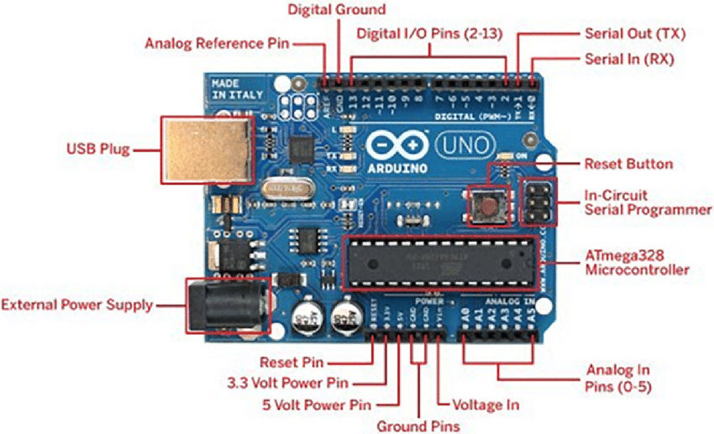

*Figure 1: Arduino uno* [4]

### Sensors

A sensor is a device that measures physical input from its environment and converts it into data that can be interpreted by either a human or a machine. Most sensors are electronic (the data is converted into electronic data), but some are simpler, such as a glass thermometer, which presents visual data. People use sensors to measure temperature, gauge distance, detect smoke, regulate pressure and a myriad of other uses. There are two types of electronic sensors: analog and digital. Analog sensors convert physical data into an analog signal. While digital sensors are limited to a finite set of possible values.  While designing this project both types of sensors were used, we used IR sensors, ultrasonic sensor [5]

#### IR sensor/ infrared sensor

IR sensor is an electronic device, that emits the light in order to sense some object of the surroundings. An **IR sensor** can measure the heat of an object as well as detects the motion. Usually, in the **infrared spectrum**, all the objects radiate some form of thermal radiation. These types of radiations are invisible to our eyes, but infrared sensor can detect these radiations.

The emitter is simply an IR LED **(Light Emitting Diode)** and the detector is simply an IR photodiode. Photodiode is sensitive to IR light of the same wavelength which is emitted by the IR LED. When IR light falls on the photodiode, the resistances and the output voltages will change in proportion to the magnitude of the IR light received.

There are five basic elements used in a typical infrared detection system: an infrared source, a transmission medium, optical component, infrared detectors or receivers and signal processing. Infrared lasers and Infrared LED’s of specific wavelength used as infrared sources.

The three main types of media used for infrared transmission are vacuum, atmosphere and optical fibers. Optical components are used to focus the infrared radiation or to limit the spectral response [5].

**Types of IR Sensor**

There are two types of IR sensors are available and they are,

* Active Infrared Sensor
* Passive Infrared Sensor

**IR Sensor Working Principle**

There are different types of infrared transmitters depending on their wavelengths, output power and response time. An IR sensor consists of an IR LED and an IR Photodiode, together they are called as PhotoCoupler or OptoCoupler.

**IR Transmitter or IR LED**

Infrared Transmitter is a light emitting diode (LED) which emits infrared radiations called as IR LED’s. Even though an IR LED looks like a normal LED, the radiation emitted by it is invisible to the human eye.

[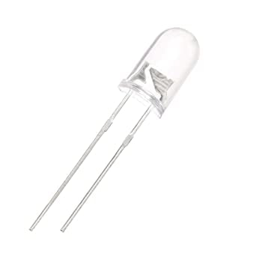](https://robu.in/wp-content/uploads/2020/05/51fibl-5xL._SX342_.jpg)

Figure 2: IR transmitter [5]

**IR Receiver or Photodiode**

Infrared receivers or infrared sensors detect the radiation from an IR transmitter. IR receivers come in the form of photodiodes and phototransistors. Infrared Photodiodes are different from normal photo diodes as they detect only infrared radiation. Below image shows the picture of an IR receiver or a photodiode,

[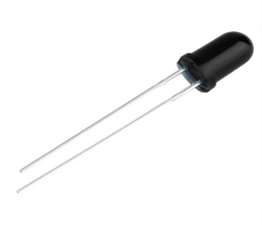](https://robu.in/wp-content/uploads/2020/05/SN-IR-R-0-1-1-800x800-1.jpg)

Figure 3:IR receiver [5]

Different types of IR receivers exist based on the wavelength, voltage, package, etc. When used in an infrared transmitter – receiver combination, the wavelength of the receiver should match with that of the transmitter.

The emitter is an IR LED and the detector is an IR photodiode. The IR photodiode is sensitive to the IR light emitted by an IR LED. The photo-diode’s resistance and output voltage change in proportion to the IR light received. This is the underlying working principle of the IR sensor [5].

[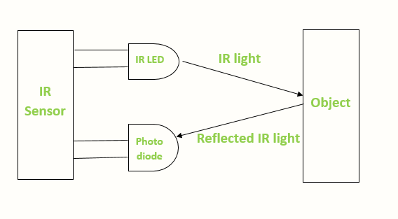](https://robu.in/wp-content/uploads/2020/05/IR-sensor-Working.png)

Figure 4:IR sensor obstacle detection [5]

When the IR transmitter emits radiation, it reaches the object and some of the radiation reflects back to the IR receiver. Based on the intensity of the reception by the IR receiver, the output of the **sensor** defines.

**Advantages**

The advantages of IR sensor include the following

* It uses less power
* The detection of motion is possible in the presence or absence of light approximately with equal reliability.
* They do not need contact with the object for detection
* There is no data leakage because of the ray direction
* These sensors are not affected by oxidation & corrosion
* Noise immunity is very strong

**Disadvantages**

The **disadvantages of IR sensor** include the following

* Line of sight is required
* Range is limited
* These can be affected by fog, rain, dust, etc
* Less data transmission rate

#### HC-SR04 Ultrasonic sensor .

HC-SR04 Ultrasonic sensor is a 4 pin module, whose pin names are Vcc, Trigger, Echo and Ground respectively. This sensor is a very popular sensor used in many applications where measuring distance or sensing objects are required. The module has two eyes like projects in the front which forms the Ultrasonic transmitter and Receiver. The sensor works with the simple high school formula that

**Distance = Speed × Time**

The Ultrasonic transmitter transmits an ultrasonic wave, this wave travels in air and when it gets objected by any material it gets reflected back toward the sensor this reflected wave is observed by the Ultrasonic receiver module as shown in the picture below [5]

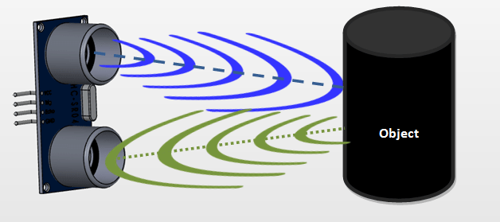

Figure 5:Ultrasonic sensor

To calculate the distance using the above formula, the Speed and time in known. Since universal speed of US wave at room conditions which is 330m/s. The circuitry inbuilt on the module will calculate the time taken for the US wave to come back and turns on the echo pin high for that same particular amount of time, this way we can also know the time taken. the distance is then calculated using a microcontroller or microprocessor.

**Applications**

* Used to avoid and detect obstacles with robots like biped robot, obstacle avoider robot, path finding robot etc.
* Used to measure the distance within a wide range of 2cm to 400cm
* Can be used to map the objects surrounding the sensor by rotating it
* Depth of certain places like wells, pits etc can be measured since the waves can penetrate through water

### Actuators

An actuator is a component of a machine that is responsible for moving and controlling a mechanism or system, for example by opening a valve. An actuator requires a control signal and a source of energy. The control signal is relatively low energy and may be electric voltage or current, pneumatic, or hydraulic fluid pressure, or even human power. Its main energy source may be an electric current, hydraulic pressure, or pneumatic pressure. When it receives a control signal, an actuator responds by converting the source's energy into mechanical motion, while implementing this project we used motors [6]

#### DC motor

The term ‘DC motor’ is used to refer to any rotary electrical machine that converts direct current electrical energy into mechanical energy. DC motors can vary in size and power from small motors in toys and appliances to large mechanisms that power vehicles, pull elevators and hoists, and drive steel rolling mills. DC motors include two key components: a **stator** and an **armature**. The stator is the stationary part of a motor, while the armature rotates. In a DC motor, the stator provides a rotating magnetic field that drives the armature to rotate.

A simple DC motor uses a stationary set of magnets in the stator, and a coil of wire with a current running through it to generate an electromagnetic field aligned with the center of the coil. One or more windings of insulated wire are wrapped around the core of the motor to concentrate the magnetic field.

The windings of insulated wire are connected to a commutator (a rotary electrical switch), that applies an electrical current to the windings. The commutator allows each armature coil to be energized in turn, creating a steady rotating force (known as torque).

When the coils are turned on and off in sequence, a rotating magnetic field is created that interacts with the differing fields of the stationary magnets in the stator to create torque, which causes it to rotate. These key operating principles of DC motors allow them to convert the electrical energy from direct current into mechanical energy through the rotating movement, which can then be used for the propulsion of objects [6]

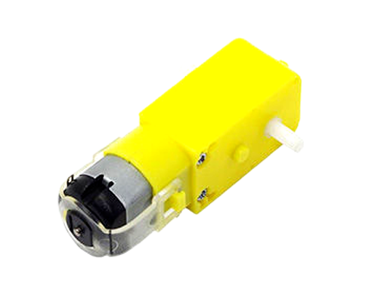

Figure 6: DC electric motor [6]

### Switching devices

switching devices are defined as any devices that open and close electrical circuits. Electrical circuits must form a continuous loop, and a switching device functions like a gate in that loop. A circuit is ON when the switching device is closed, and the circuit is OFF when the switching device is open. In this project we used different kind of switching devices such as pushbuttons, relay board and selector switch [7]

#### L298N Driver

The L298N is a dual H-Bridge motor driver which allows speed and direction control of two DC motors at the same time. The module can drive DC motors that have voltages between 5 and 35V, with a peak current up to 2A [8].

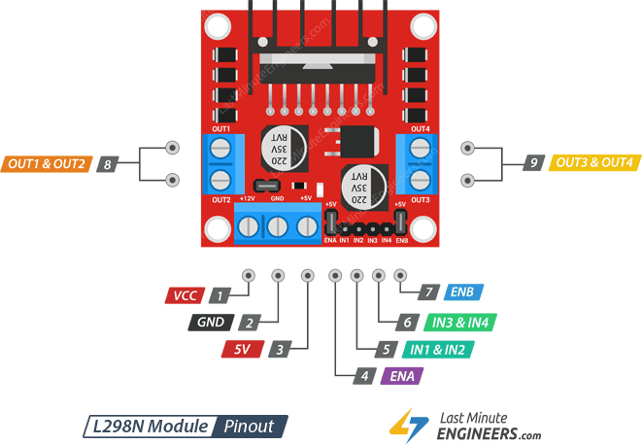

Figure 7:L298N motor driver [8]

VCC  pin supplies power for the motor. It can be anywhere between 5 to 35V. Remember, if the 5V-EN jumper is in place, you need to supply 2 extra volts than motor’s actual voltage requirement, in order to get maximum speed out of your motor.

GND  is a common ground pin.

5V  pin supplies power for the switching logic circuitry inside L298N IC. If the 5V-EN jumper is in place, this pin acts as an output and can be used to power up your Arduino. If the 5V-EN jumper is removed, you need to connect it to the 5V pin on Arduino.

ENA  pins are used to control speed of Motor A. Pulling this pin HIGH (Keeping the jumper in place) will make the Motor A spin, pulling it LOW will make the motor stop. Removing the jumper and connecting this pin to PWM input will let us control the speed of Motor A.

IN1 & IN2  pins are used to control spinning direction of Motor A. When one of them is HIGH and other is LOW, the Motor A will spin. If both the inputs are either HIGH or LOW the Motor A will stop.

IN3 & IN4  pins are used to control spinning direction of Motor B. When one of them is HIGH and other is LOW, the Motor B will spin. If both the inputs are either HIGH or LOW the Motor B will stop.

ENB  pins are used to control speed of Motor B. Pulling this pin HIGH(Keeping the jumper in place) will make the Motor B spin, pulling it LOW will make the motor stop. Removing the jumper and connecting this pin to PWM input will let us control the speed of Motor B.

OUT1 & OUT2 pins are connected to Motor A.

OUT3 & OUT4 pins are connected to Motor B

#### 5VDC Relay

A relay is an electrically operated switch. It consists of a set of input terminals for a single or multiple control signals, and a set of operating contact terminals. The switch may have any number of contacts in multiple contact forms, such as make contacts, break contacts, or combinations

Relays are used where it is necessary to control a circuit by an independent low-power signal, or where several circuits must be controlled by one signal [8].

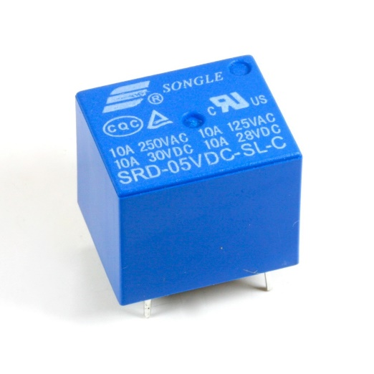

Figure 8:Relay

#### Transistors

A transistor is a semiconductor device used to amplify or switch electrical signals and power. The transistor is one of the basic building blocks of modern electronics. It is composed of semiconductor material, usually with at least three terminals for connection to an electronic circuit. A voltage or current applied to one pair of the transistor's terminals controls the current through another pair of terminals. Because the controlled (output) power can be higher than the controlling (input) power, a transistor can amplify a signal. Some transistors are packaged individually, but many more are found embedded in integrated circuits [9].

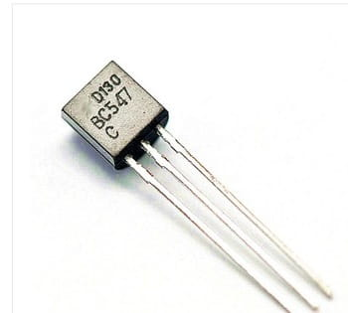

Figure 9:NPN transistor BC547 [9]

# **CHAPTER THREE: METHODOLOGY**

## 3.1 Introduction

This chapter demonstrates different methods and strategies that were used to conduct this project, we highlighted the methods which are interview, observation method and documentation methods. Furthermore, we reviewed different softwares and programming languages that were also used while designing and implementing this project.

## Methodology

### Observation

Observation, as the name implies, is a way of collecting data through observing. Observation data collection method is classified as a participatory study, because the researcher has to immerse him/herself in the setting where her respondents are, while taking notes and/or recording. The advantages of observation data collection method include direct access to research phenomena, high levels of flexibility in terms of application and generating a permanent record of phenomena to be referred to later. At the same time, observation method is disadvantaged with longer time requirements, high levels of observer bias, and impact of observer on primary data, in a way that presence of observer may influence the behavior of sample group elements.

While collecting the data, it was hard to visit many homes since most of them they like privacy. But we managed to observe starting from our homes and some institutions, we also observed how the business is done on the side of vendors in the business of gas refilling and gas ordering.

### Documentation

This technique is also necessary for getting information and help the researcher also to increase their knowledge so that he can easily solve the problem practically, it permits the researcher to consult books, other previous researchers, class notes, and the internet to find a different definition of words and codes for solving it.

Here we have read many class notes; consult different books from the school even outside the school so that we can easily solve the problems as stated before.

## Softwares used

Application software (app for short) is a program or group of programs designed for end-users to perform specific tasks. While designing and implementing this project we used different kind of softwares like Arduino IDE and fritzing.

### Arduino IDE

The Arduino Integrated Development Environment (IDE) is a cross-platform application (for Windows, mac OS, Linux) that is written in functions from C and C++.It is used to write and upload programs to Arduino compatible boards, but also, with the help of third-party cores, other vendor development boards. In this project Arduino IDE was used in writing and upload program to Arduino Uno [3].

# **CHAPTER FOUR: PRESENTATION AND RESULT ANALYSIS**

## Introduction

Using the components, softwares discussed automatic fork lift with speed control was designed and implemented.

## Block diagram

**ARDUINO UNO**

POWER SUPPLY

L298 MOTOR DRIVER

ULTRASONIC

SENSOR

IR SENSOR

**LIFT MECHANISM**

Figure 10: block diagram

### Block diagram description

The basic block diagram of IoT BASED SMART GAS MONITORING SYSTEM as shown above is composed of different main blocks:

#### 4.2.1.1 Arduino UNO

As discussed the Arduino Uno is a micro controller board based on the aTmega328, this microcontroller in the above block diagram, manages the communication between different input and output devices, reads data from the sensors, writes data on the output devices furthermore it makes logical decision based on the input from sensors and also the program written on it.

#### Infrared sensors

Concept of working of line follower is related to light. We use here the behavior of light at black and white surface. When light fall on a white surface it is almost full reflected and in case of black surface light is completely absorbed. This behavior of light is used in building a line follower robot.

[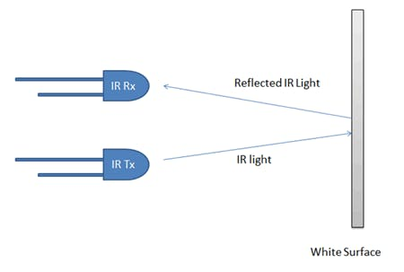](javascript:openLightBox('7a75fcf827',%200);)

[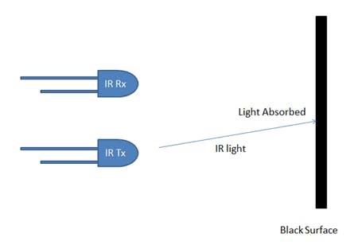](javascript:openLightBox('446cf4ff30',%200);)

Figure 11:IR sensor on a black and white surface

Designing the line follower robot three Infared sensors were used, these are responsible for sensing the black line and then the microcontroller controls the motors based on the values obtained from the sensors.

**FORWARD**

**Turn left**

**Turn right**

**Stop**

Figure 12:IR sensors on different directions

#### Ultrasonic sensor

The ultrasonic sensor as discussed earlier it  it can be used to measure the distance by the use of sound waves, specifically in this project, this sensor was used to sense if there is an object to carry, and it was also used as an obstacle avoider.

#### Lift mechanism

The lift mechanism is composed of a dc motor, gears and two relays to put the motor in forward and reverse.

## Flow chart

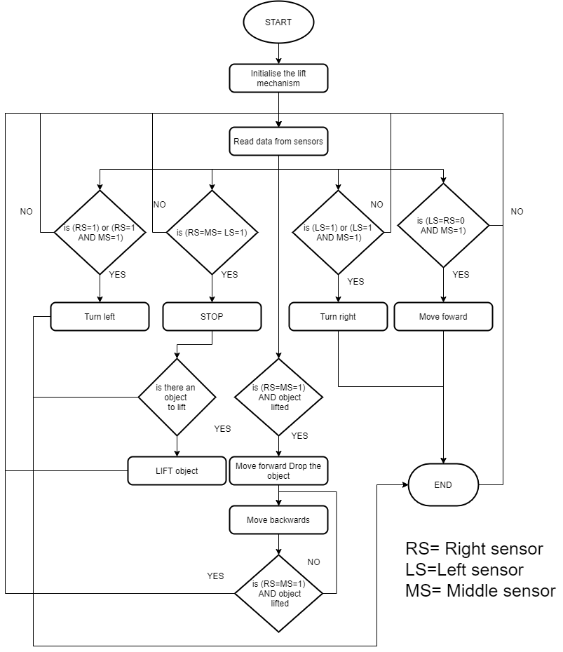

Figure 13: flow chart

## 4.4 Circuit diagram

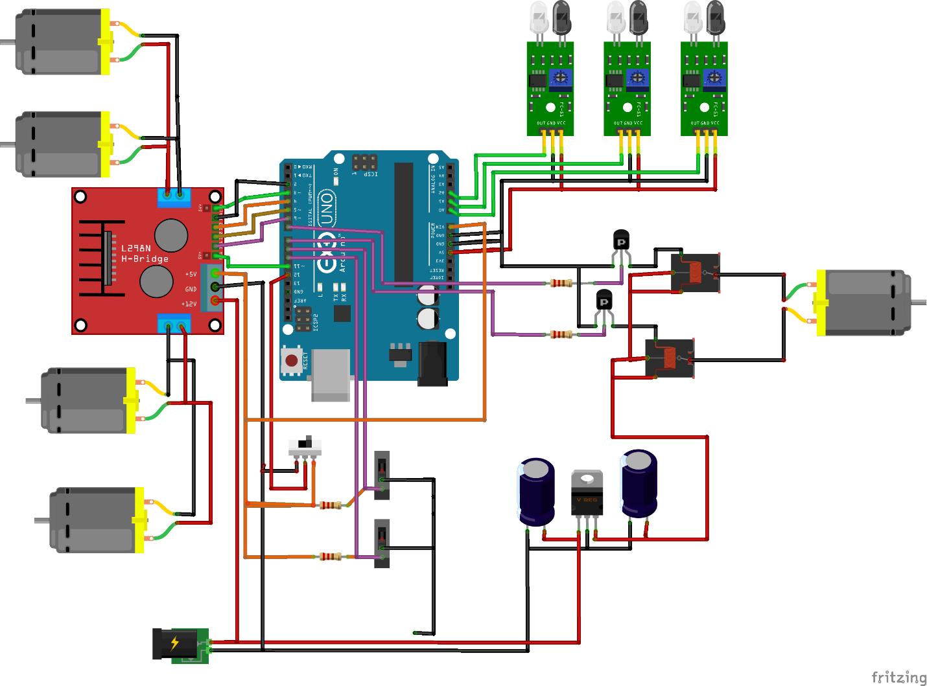

Figure 14: Full circuit diagram

## 4.5 working principle

When the robot is switched on, it first starts by initializing the lift mechanism, then the microcontroller starts reading the values from the IR sensors, depending on the values obtained form the sensors the microcontroller then commands the robot to stop, move forward, move backwards, turn left or turn right.

When all the three IR sensors are sensing the black line, the robot stops it then checks if there is an object to carry, when there is an object the robot moves forward, moved down the lifting mechanism, picks up the object then follows the line accordingly.

* If the right sensor or the right and the middle sensor are sensing the black line, the robot turns left.
* If the left sensor or the left and the middle sensor are sending the black line, then the robot turns Right.
* If the right sensor and the left sensor are not sensing the black line but the middle sensor is sensing the black line the robot moves forward.
* If the right sensor and the middle sensor senses the black line while the robot has lifted the object, then the robot stops, moves forward, reaches the drop are marked by a black line, drops the object, moves backwards till it senses the black line, and again it starts following the line.

The speed of the robot can be changed by toggling the toggle switch, either to choose high speed or low speed.

## Implementation of the project

While implementing this project, we started by testing component on breadboard then after testing we soldered the whole circuit on PCB after all we mounted the car body with the motors and also mounted the circuit.

Figure 15: final implemented project

# **CHAPTER FIVE. CONCLUSION, SUMMARY AND RECOMMENDATION**

## Conclusion

The project that we have undertaken has helped us gain a better perspective on various aspects related to our course of study as well as practical knowledge on electronic components, we became familiar with software analysis, designing, implementing, testing and maintaining while carrying out this project, we also improved on team working which of course became the pillar to successfully achieving this project. This project can be helpful in packaging in hazard areas since it can work without human intervening.

## Recommendation

1. This project is an implication of our concept in automating, the lifting of loads using a robot, we recommend that this project can be applied more especially in places that are dangerous to humans to work in.
2. We recommend my fellow brothers and sisters to explore more in the field of IoT since there is more to learn and this world is tending to prefer IOT systems more.
3. This system can be improved by designing a mobile application where it can be controlled remotely
4. This system can also be improved by using QR code reader to read the places where it can exactly place the object.

# **REFERENCES**

|  |  |
| --- | --- |
| [1] | J. F. Margaux Baum, "The History of Robots and Robotics," in *Hands-On Robotics*, New York, United, The Rosen Publishing Group, Inc, , 2017. |
| [2] | S. Block, "Digital control methods for a line following robot," Newyork,USA, diplom.de, 2003, 2003. |
| [3] | R. Kamal, "Microcontrollers: Architecture, Programming, Interfacing and System Design," in *Microcontrollers: Architecture, Programming, Interfacing and System Design*, Pearson Education India, 2009, 2009. |
| [4] | A. Kurniawan, "Arduino UNO WiFi Development Workshop," in *Arduino UNO WiFi Development Workshop*, PE Press, 2016. |
| [5] | A. R. John Vetelino, "Introduction to Sensors," CRC Press, 2017, 2017. |
| [6] | C. W. d. Silva, "Sensors and Actuators: Engineering System Instrumentation, Second Edition," in *Sensors and Actuators: Engineering System Instrumentation, Second Edition*, CRC Press, 2015, 2015. |
| [7] | J. Rupp, "Resistive Switching: Oxide Materials, Mechanisms, Devices and Operations," in *Resistive Switching: Oxide Materials, Mechanisms, Devices and Operations*, Springer Nature, 2014. |
| [8] | C. W. d. Silva, "Mechatronic Systems: Devices, Design, Control, Operation and Monitoring," in *Mechatronic Systems: Devices, Design, Control, Operation and Monitoring*, CRC Press, 2007, 2007. |
| [9] | H. E. Marrows, "Transistor Engineering Reference Handbook," in *Transistor Engineering Reference Handbook*, J.F. Rider, 1956, 2002. |

# **APPENDIES**

APPENDIX ONE

Project codes

APPENDIX TWO

PROJECT BUDGET

|  |  |  |  |  |
| --- | --- | --- | --- | --- |
|  | **ITEM** | **QTY** | **PRICE/UNITY** | **TOTAL PRICE** |
| 1 | ARDUINO UNO | 1 | 11,000 | 12,000 |
| 2 | CAR WHEELS | 4 | 3,500 | 14,000 |
| 3 | CAR BODY | 1 | 6,000 | 6,000 |
| 4 | TRANSISTORS | 2 | 3,00 | 6000 |
| 5 | MOTOR DRIVER | 1 | 4,500 | 4,500 |
| 6 | RELAY 8PIN | 1 | 2,2000 | 2,200 |
| 7 | RELAY | 1 | 1,000 | 1,000 |
| 8 | BATTERY | 3 | 4,000 | 12,000 |
| 9 | L7806 | 1 | 500 | 500 |
| 10 | CAPACITORS | 2 | 500 | 1,000 |
| 11 | LIMIT SWITCH | 2 | 1,500 | 3,000 |
| 12 | SWITCH | 1 | 400 | 400 |
| 13 | IR LINE SENSORS | 3 | 4,500 | 12,500 |
| 14 | MOTOR | 1 | 3,000 | 3,000 |
| 16 | WIRES | 20 | 50 | 1,000 |
| 17 | PCB | 1 | 1,000 | 1,000 |
| 25 | TRANSPORT |  |  | 15,000 |
| 26 | COMMUNICATION |  |  | 10,000 |
| 27 | BREAD BOARD | 1 | 4,000 | 4,000 |
|  | LIFT MECHANISM | 1 | 3,000 | 3,000 |
|  |  |  | TOTAL | 106,100 |